1. **Write API to create mentor**

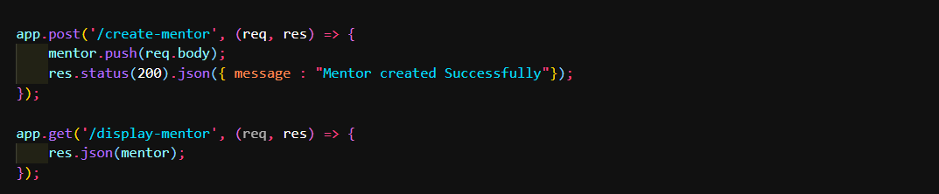

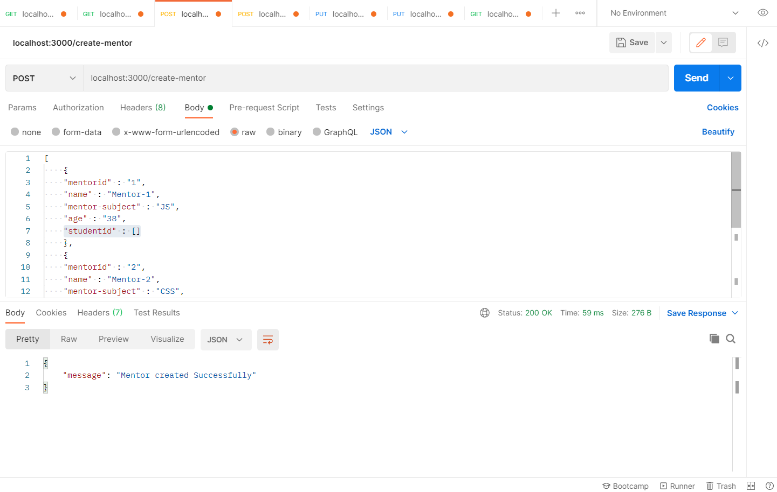

**2.Write API to create student**

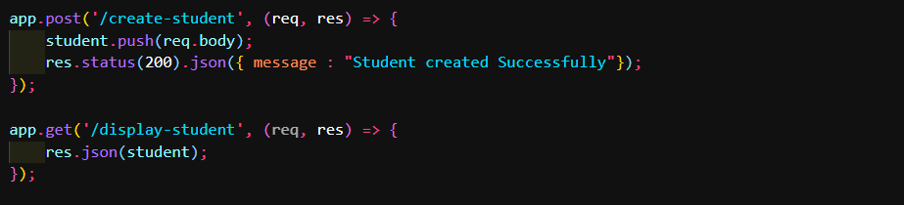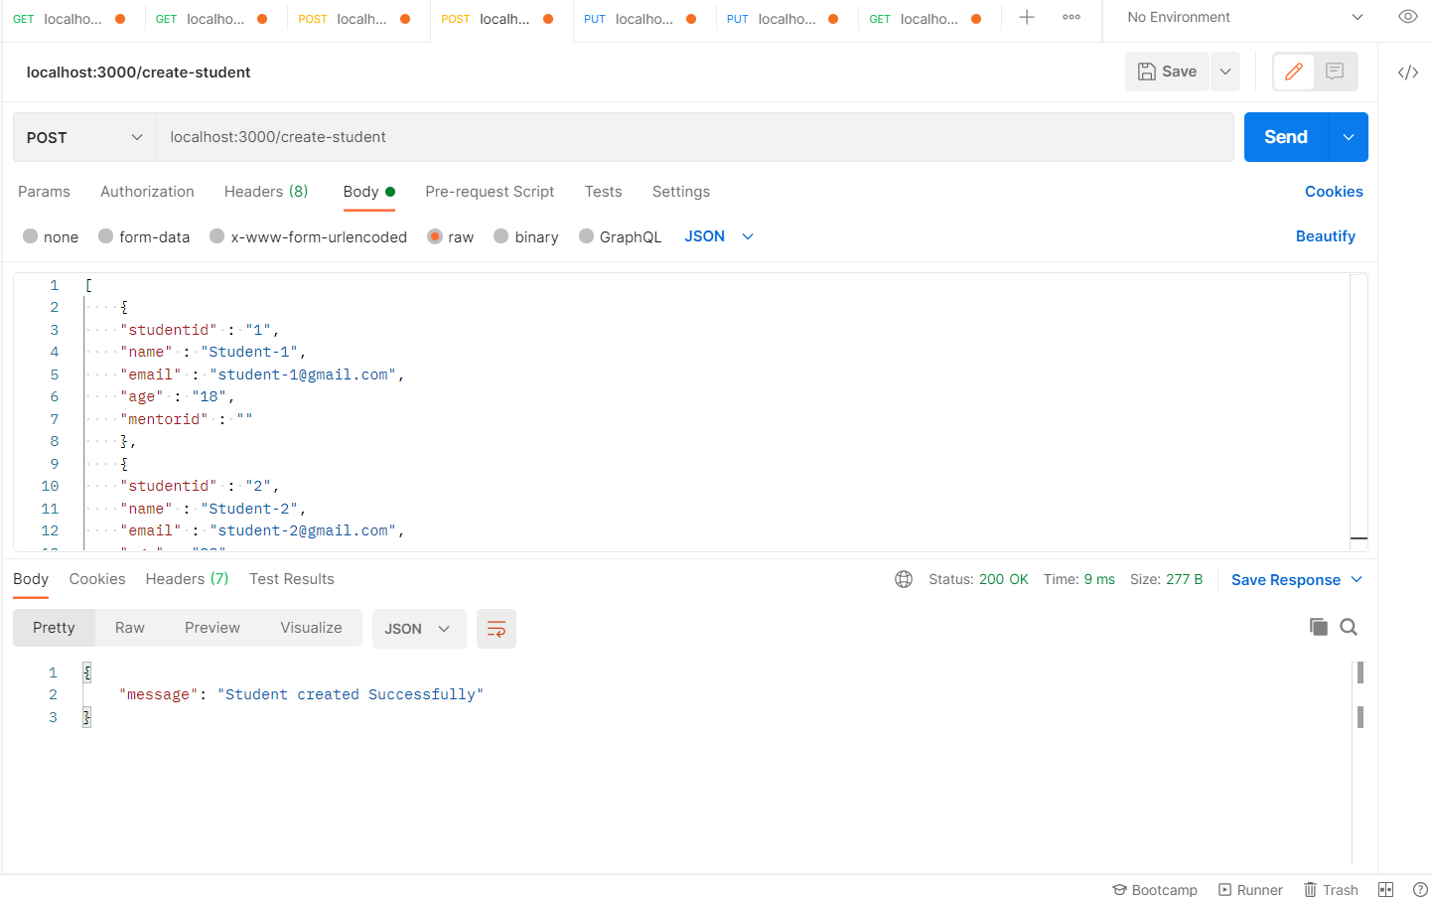

**3.Write API to assign mentor to student**

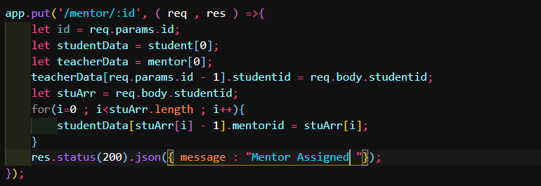

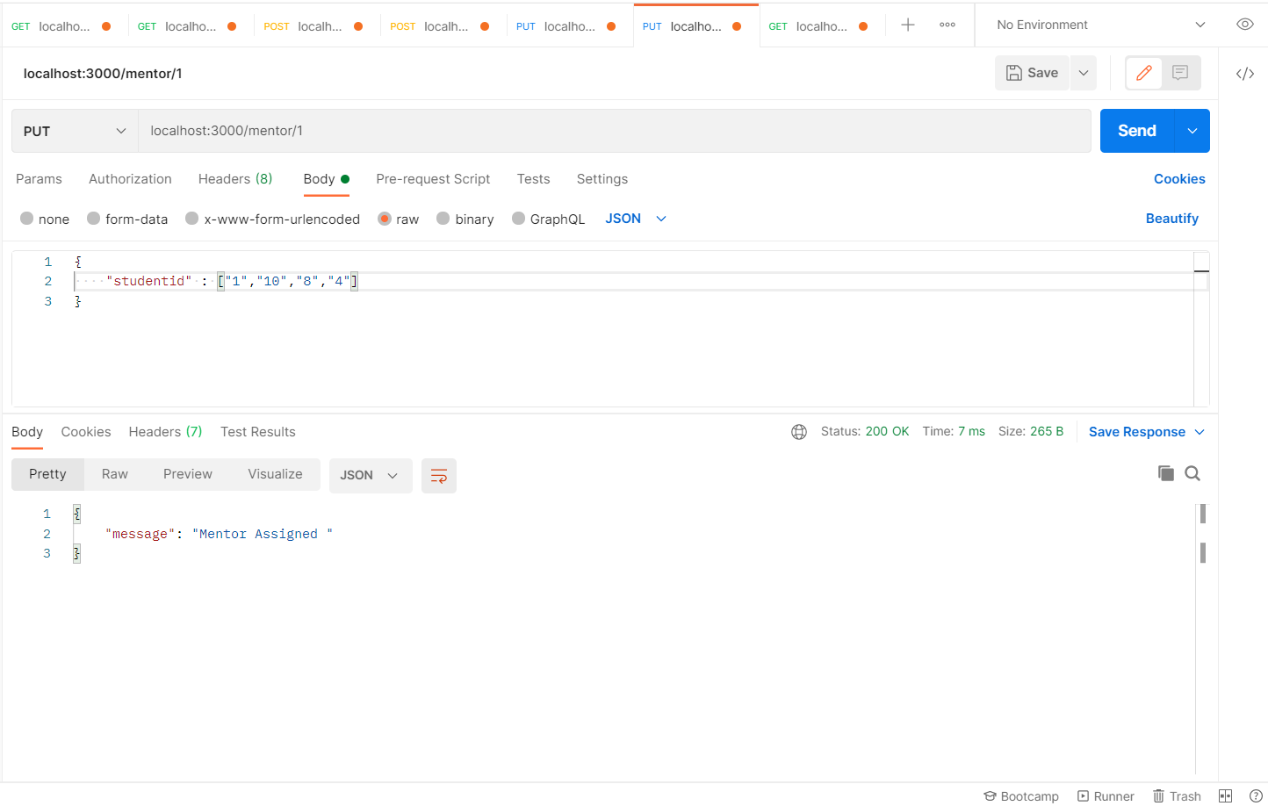

**4.Write API to assign student to a mentor**

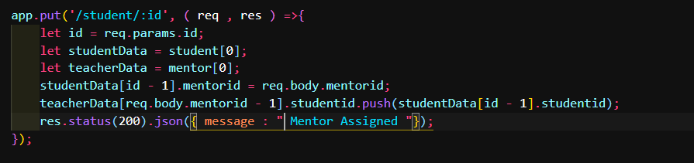

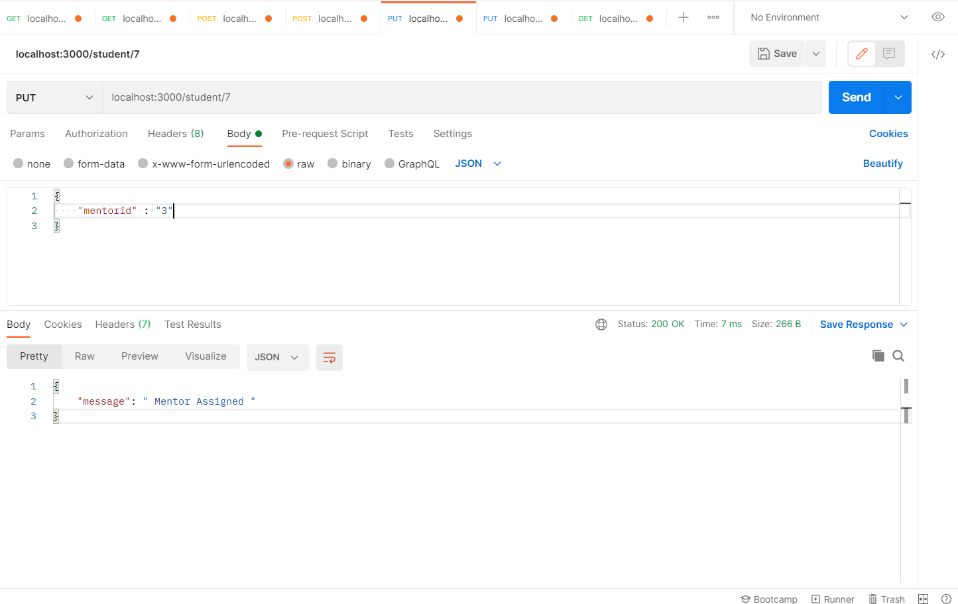

**5.Write API to show all students for a particular mentor**

